**Future of Reinforcement Learning in Banking and Finance**

Over the last few years, the applications of reinforcement learning are creating countless innovations for various industries. For the banking and finance industry, the use of these applications is fast taking over with multiple solutions for now and the future. The benefits offered by reinforcement learning to numerous banking and finance applications are helpful and are already shaping the future.

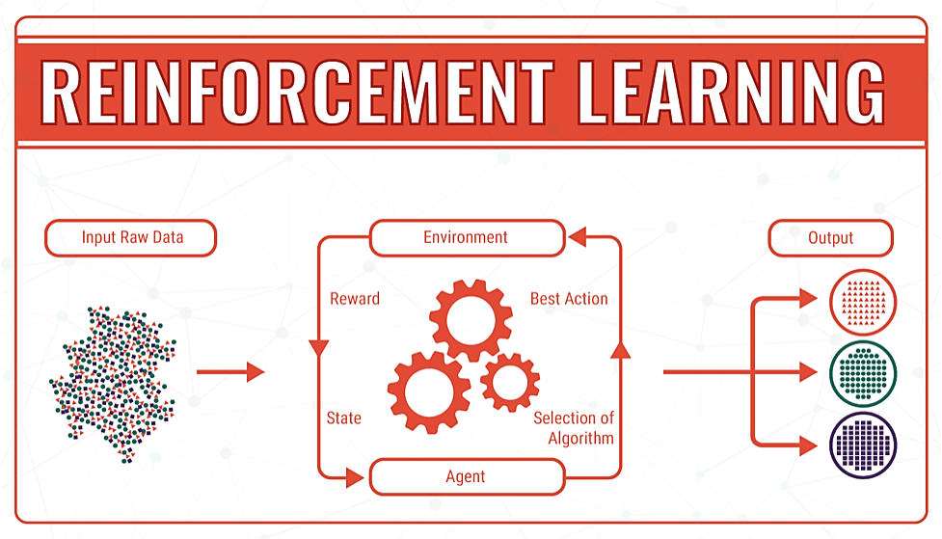

Fig. Reinforcement learning block diagram

Some significant benefits of reinforcement learning to the present-day banking and finance sector includes the creation of several in-depth invents to most financial applications. The society today is seeing a lot more possibilities when it comes to banking, chatbots, search engine tools, and wealth management. Once it comes to reinforcement learning, there are several ways in which future applications are focusing on to deliver better services. Some key areas include better customer service experience, lessened costs, and offering a better Return on Investment (ROI). These improvements are helpful to most of reinforcement learning plans.

The creation of a base for more precise forecasts into stocks and interrelated investments can become a more lucrative offer for banking and finance in the future. The reinforcement learning framework is set to offer evocative applications in finance and trading due to the following reasons:

* The size of a quantitative environmental description in finance may be massive or even constant.
* Actions may feature long-term effects, not directly computable by other supervised learning methods.
* Trader actions may affect present marketplace settings

Of late, [OpenAI](https://openai.com/), an AI research brand created [OpenAI Gym](https://gym.openai.com/), a tool for comparing and developing learning algorithms. Although its finance applications are still in the early phase, some have tried creating models based on its framework. One notable example is Q-Trader created by [Edward Lu](https://github.com/edwardhdlu/q-trader), as a deep reinforcement learning model.

One big reason why several investors are tending towards the use of reinforcement learning is its ability to evaluate financial marketplaces to create better accuracy and detailed result. The use of reinforcement learning applications towards better portfolio management like [‘Robo-advisors’](https://www.gulaq.com/robo-advisors-the-future-of-investing/) is considered to be generating even higher efficiency with time. With several approaches to spreading investments, the usage of reinforcement learning in the future would create better investment plans in comparison to human advisors.

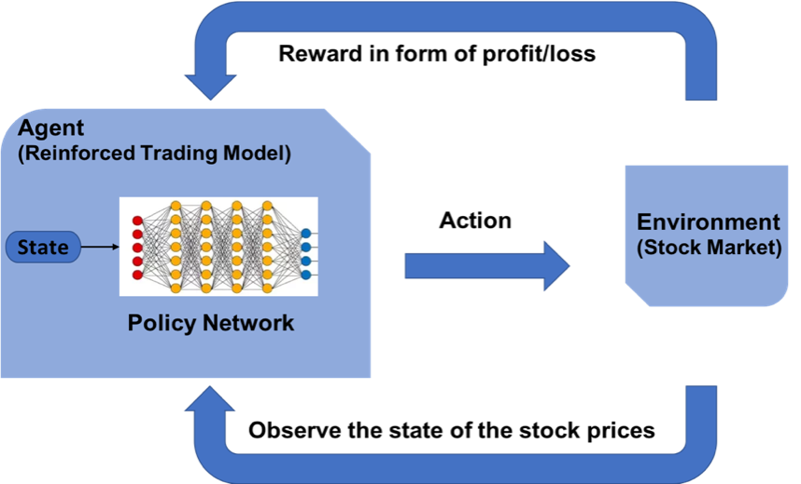

Fig. [*Reinforcement learning trading model*](https://medium.com/inside-machine-learning/reinforcement-learning-the-business-use-case-part-2-c175740999)

Reinforcement learning models are being used to offer highly accurate and tailored insights over time by using feedback from users and by observing behavioral patterns in user data. Reinforcement learning is being applied to wealth management services by personalization —a method of helping financial advisors identify the investment preferences of a client and provide bespoke advice at a level that was not imaginable before. This might involve taking into account factors such as stated, detected, and inferred information around client goals and their attitude towards risk, or by engagement — which help wealth advisors connect with the best insights for a client at an ideal time and channel.

Leading business firm, IBM, deployed an open, multi-cloud platform that lets users automate the AI lifecycle. The IBM Watson to improve risk management across financial firms. Armanta, IBM’s AI powered advisor aims to manage market, credit and liquidity risk that are associated with portfolios. Another tool from the Watson is being used in some areas of financial crimes and fraud where there are Financial Crimes Insight Engine, a platform for finding patterns of fraud and market abuse. The Watson encompasses a risk, compliance, risk management -- and all these risks are managed.

Alpha-Sense, an AI driven company based in New York provides a platform where brokers and traders can have access to information on both private and public companies such as SEC and global filings, earning call transcripts, and press releases. It also equips its users with the ability to research and discover trends in financial markets.

Reinforcement Learning in finance is improving [chatbot](https://algorithmxlab.com/blog/2018/03/19/use-chatbots-banking/) experiences, which sequentially enhance customer experience. It offers a new life into human-to-machine interaction thanks to its ability to learn from previous interactions. They are user-friendly and are beneficial to all users – customers and the finance industry alike. [Kasisto](https://kasisto.com/) uses a chatbot to monitor personal finances. Some leading banks, like [Wells Fargo](https://www.chatbotguide.org/wells-fargo-bot/), are also benefiting from this strategic technology. [Bank of America](https://promo.bankofamerica.com/erica/) also developed its bot, Erica.

The design of algorithms in allocating limited resources involves several tasking processes and requirements. The [paper on Resource Management](https://people.csail.mit.edu/alizadeh/papers/deeprm-hotnets16.pdf) shows how RL automatically learn to allot and schedule resources effectively while also minimizing the average job slowdown. The formulation of State-space to current resource allocation assists in the resource profile of jobs. For action space, this application allows the agent to select multiple actions at a time. It also delivers the best policy parameters that serve probability distribution in minimizing objective.

With several risk factors out there today, there seem not to be enough resources to tackle these security threats effectively. But the use of reinforcement learning for future systems would lead to lesser security challenges. This feature is down to the fact that most systems available today are only able to detect specific activities with consideration to laid down rules and regulations. A future reinforcement learning would be set-up to be able to detect fraud itself. Emergency risk and probable security challenges can get flagged in time. The technology developments during the last years have shown great promise for reinforcement learning to take over from present systems. Such a takeover would come with zero worries about fraud or security cracks. There are many more promises with reinforcement learning, and with the proper techniques implemented, we all can expect much more going onward.

Reinforcement learning takes a similar algorithm approach to machine learning. Such algorithms let Banking and Finance systems to make the most of its performance in improving Customer Experience. In the future, real-world applications would make use of deep reinforcement learning to and pick up user habits to aid in improving the overall experience. The knowledge and memorization gained over time would allow for the creating of more precise systems for customers within the financial sectors.

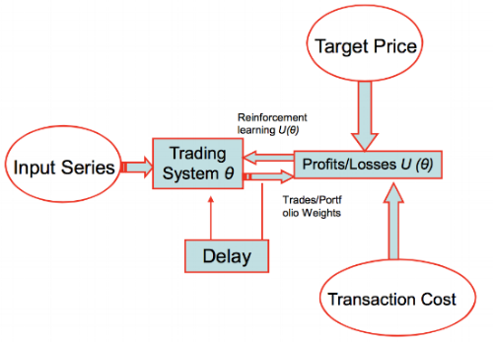

Fig. [Reinforcement Learning](http://cs229.stanford.edu/proj2009/LvDuZhai.pdf) based Financial Advisor

Relying on reinforcement learning also comes with its consequences. Reinforcement learning relies solely on data. Once data is tampered with, the model will be inaccurate and give false info, probably leading to a significant loss. Its dependence on the state of current input in decides its output. Without correct data of the present state, results or production can only give predictions and outcomes based on them.

By 2020, [Gartner predicts a massive 84%](https://www.gartner.com/en/newsroom/press-releases/2018-02-19-gartner-says-25-percent-of-customer-service-operations-will-use-virtual-customer-assistants-by-2020) of customer dealings with any enterprise will happen without another human interaction. Reinforcement Learning is set to drive the banking and finance sector into one who can leverage technology to enhance its services to the end-user.

Nevertheless, its benefits go past its implications on ultimate customer experience. Reinforcement learning for the future is seeking a more comprehensive application into major systems and processes. With practical solutions to data breaches, security threats, and more, the future is set to witness a significantly lower risk level. Also, better predictability and decision-making process for banking and finance is set to benefit from reinforcement learning in the future massively.